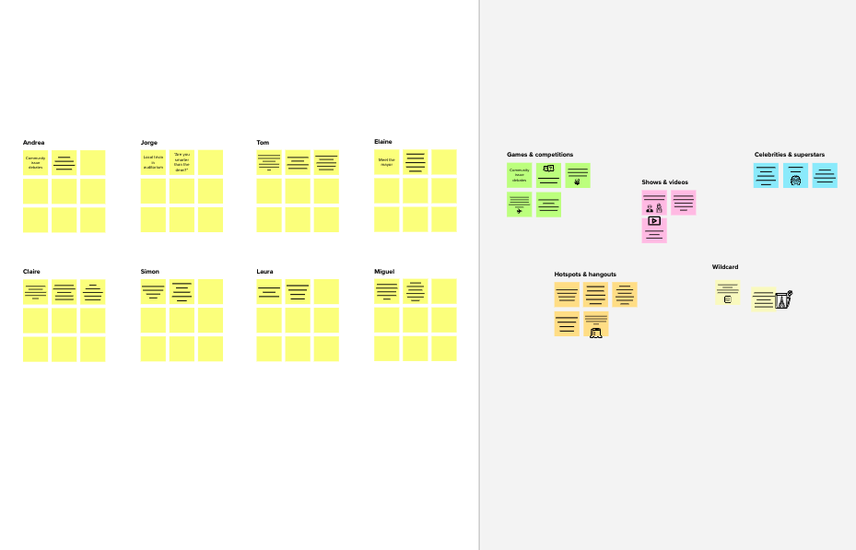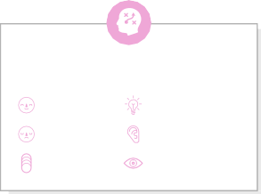

**Brainstorm**

**& idea prioritization**

Use this template in your own brainstorming sessions so your team can unleash their imagination and start shaping concepts even if you're not sitting in the same room.

## Before you collaborate

A little bit of preparation goes a long way with this session. Here’s what you need to do to get going.

**10 minutes**

**TEAM ID:PNT2022TMID13627**

1. **Team gathering**

Define who should participate in the session and send an invite. Share relevant information or pre-work ahead.

1. **Set the goal**

Think about the problem you'll be focusing on solving in the brainstorming session.

1. **Learn how to use the facilitation tools**

Use the Facilitation Superpowers to run a happy and

**1**

## Define your problem statement

What problem are you trying to solve? Frame your problem as a How Might We statement. This will be the focus of your brainstorm.

**5 minutes**

**PROBLEM**

**How might we [your problem statement]?**

**2**

## Brainstorm

Write down any ideas that come to mind that address your problem statement.

**10 minutes**

**SARAVANASUDHAN.S**

The proposed system would be able to automate the solid waste monitoring process and management of the overall collection process using IOT (Internet of Things).

Placing Ultrasonic sensor to detect level of bins

**TIP**

You can select a sticky note and hit the pencil [switch to sketch] icon to start drawing!

Waste generation analysis to understand cities usages

Enable GPS function to locate bins easier

**3**

## Group ideas

Take turns sharing your ideas while clustering similar or related notes as you go. Once all sticky notes have been grouped, give each cluster a sentence-like label. If a cluster is bigger than six sticky notes, try and see if you and break it up into smaller sub-groups.

**20 minutes**

**4**

## Prioritize

Your team should all be on the same page about what's important moving forward. Place your ideas on this grid to determine which ideas are important and which are feasible.

**20 minutes**

## After you collaborate

You can export the mural as an image or pdf to share with members of your company who might find it helpful.

### Quick add-ons

1. **Share the mural**

**Share a view link** to the mural with stakeholders to keep them in the loop about the outcomes of the session.

1. **Export the mural**

Export a copy of the mural as a PNG or PDF to attach to emails, include in slides, or save in your drive.

**10 minutes** to prepare

**1 hour** to collaborate

**2-8 people** recommended

productive session.

[**Open article**](https://support.mural.co/en/articles/2113740-facilitation-superpowers)

**TIP**

Add customizable tags to sticky notes to make it easier to find, browse, organize, and categorize important ideas as themes within your mural.

### Key rules of brainstorming

Waste generation analysis to understand cities usages

To run an smooth and productive session

# TAMIL INIAN.R

Place Arduion board at left side of bins

Load cell on bottom of bins

**NAVEEN**

Visual fill status indicators on top of bins

### Keep moving forward

**Strategy blueprint**

Define the components of a new idea or strategy.

[**Open the template**](https://app.mural.co/template/e95f612a-f72a-4772-bc48-545aaa04e0c9/984865a6-0a96-4472-a48d-47639307b3ca)

**Customer experience journey map**

Understand customer needs, motivations, and

Stay in topic. Defer judgment.

Encourage wild ideas. Listen to others.

### Importance

using by GSM in bins achieve wireless communication with bins and managing center

Smart garbage maintenance server

Transparency and sustainable solution than normal garbage bins

Optimized trash collection route

If each of these

obstacles for an experience.

[**Open the template**](https://app.mural.co/template/b7114010-3a67-4d63-a51d-6f2cedc9633f/c1b465ab-57af-4624-8faf-ebb312edc0eb)

Raspberry-pi with ultrasonic, GPS, Load cell, are

configured

Go for volume. If possible, be visual.

tasks could get

done without any difficulty or cost, which would have the most positive impact?

**Strengths, weaknesses, opportunities & threats**

Identify strengths, weaknesses, opportunities, and threats (SWOT) to develop a plan.

[**Open the template**](https://app.mural.co/template/6a062671-89ee-4b76-9409-2603d8b098be/ca270343-1d54-4952-9d8c-fbc303ffd0f2)

[**Share template feedback**](https://muralco.typeform.com/to/CiqaHVat?typeform-source=app.mural.co)

their re on can ing

ng the

.

**TIP**

Participants can use cursors to point at whe sticky notes should go the grid. The facilitator confirm the spot by us the laser pointer holdi **H key** on the keyboard

IOT alert authorized person when bins going to fill

Collect only degradable and non- degradable wastes

# MOHAMEDUMAR.N

when bins fill alert message to the authorized person

solar panels for power supply for IOT devices

[**Share template feedback**](https://muralco.typeform.com/to/CiqaHVat?typeform-source=app.mural.co)

### Feasibility

Regardless of their importance, which tasks are more feasible than others? (Cost, time, effort, complexity, etc.)

**Template**

**Need some inspiration?**

See a finished version of this template to kickstart your work.

[**Open example**](https://app.mural.co/template/e5a93b7b-49f2-48c9-afd7-a635d860eba6/93f1b98d-b2d2-4695-8e85-7e9c0d2fd9b9)